**Salesforce Slack Integration Documentation and Results:**

1. **Analyze the requirements below for this integration & explain what you feel it is trying to achieve.**

*.Your company wants to be notified instantly by leveraging alerts about Salesforce records changes directly in Slack.*

*. Ensure the team you collaborate with always has the latest updates on an Account, Opportunity, or other objects on a dedicated Slack channel.*

*• Know when records are assigned to employees from Slack, along with Salesforce in-app notifications or emails.*

* 1. The goal of this integration is to successfully implement the user’s Salesforce organization and their Slack organization so they can communicate specific updates between each other. This allows for another means of communication to ensure updates are sent and acknowledged in more than one place (in this case the Salesforce organization as well as the appropriate Slack channels and users).

1. **What software or application are you testing & What does it do?** 
   1. I am testing my Salesforce Slack Integration application for my manual tests. This application integrates the functionalities of the Salesforce interface and Slack interface and allows the user to send Lead notifications that are performed in Salesforce directly to the Slack users in your organization. This can help ensure that users in your org receives notifications directly so they do not miss important or time sensitive updates.
2. **What kind of test will you be using to Test your integration?** 
   1. I will be performing *Integration Testing*. This ensures that when the Slack integration in Salesforce is executed, you can test each individually implemented module separately before testing them as a fully integrated unit.
3. **Create & present 3 Test scenarios for this integration.** 
   1. **Scenario 1:** Test that in Slack that Salesforce notifies the leads channel of newly created leads
   2. **Scenario 2:** Test that already created records can be sent directly from Salesforce to Slack
   3. **Scenario 3:** Test that users can send a hot lead update from Salesforce to Slack
4. **Create & present 3 Test cases for the 3 scenarios you have created.** 
   1. **Test Case 1:** Check that new leads can be created in Salesforce
   2. **Test Case 2:** Check that 'Send to Slack' option in Salesforce works successfully
   3. **Test Case 3:** Check that your Slack Alert for 'Ratings' updates can be received
5. **Conduct the Tests and document your findings in your bug tracking tool of your preference.**

I ran into a bug when testing the Slack Alert for the Ratings update from Salesforce to Slack. I documented this issue using the bug tracking tool Jira.

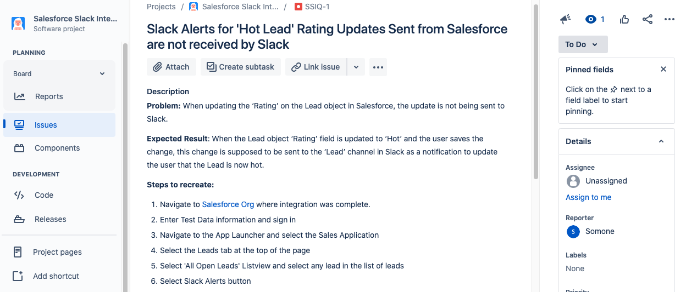

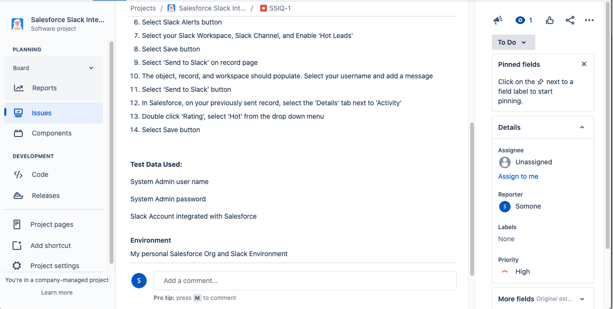

1. **Present your findings & results. ✅ - View Attached Video**
2. **Lastly, part of the process is to answer questions your audience may ask. Anticipate and create 3 questions an end-user may have and answer them to the best of your abilities. ✅**
   1. *Can you send more than one record at a time in a single Slack notification?*
      1. No, you can only send one record at a time, per person.
   2. *What other types of Slack Alert updates can be sent from Salesforce?*
      1. 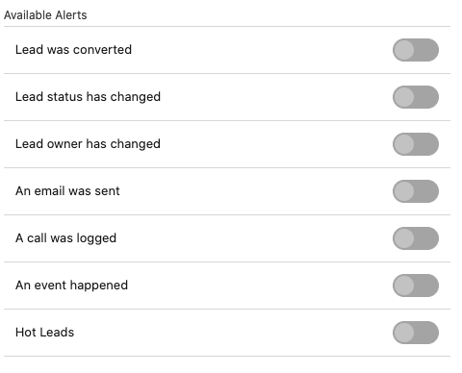
   3. *Can Slack updates from Salesforce work on Opportunities as well as Leads?*
      1. Yes, slack updates can work on Opportunities, but you will have to tweak your flow to enable this.